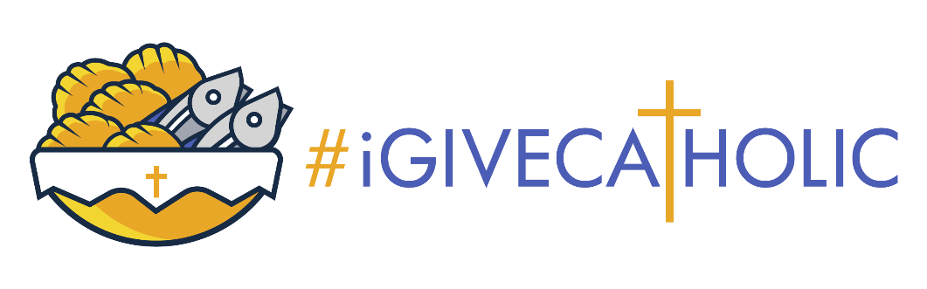
Downloadable Graphics
Downloads | #iGiveCatholic

Facebook Creator Studio Tutorial
Facebook Creator Studio Tutorial - YouTube

Facebook Creator Studio Tutorial on Scheduling Posts
https://www.youtube.com/watch?v=FMgRv6bHDcY

Sample Email:
We’re excited to announce that we are participating in #iGiveCatholic on #GivingTuesday, November 28, 2023. This is a nationally recognized, special day set aside to honor the beauty of our Catholic faith. It offers all of us the opportunity to support the many wonderful Catholic organizations that serve, such as (enter your parish/mission, school or ministry name). Join us to give thanks and give back! It is only with the prayers and generous assistance of our supporters that we are able to accomplish our important work and make a difference in the lives that we are so blessed to impact.
This year, we are seeking to raise (insert $ goal) to help fund (insert project). Any gift that you are able to make to assist us in this endeavor will be welcomed and greatly appreciated.
All gifts made to (insert your parish/mission, school or ministry name) on November 28th or during the Advanced Giving Day phase running from November 13th – November 27th either online or offline (through a gift of cash or check directly to our organization), will increase our ability to make a difference. Please help us reach our fundraising goal during #iGiveCatholic!
Follow us on (enter your social media presence links) so you can share in the excitement of our Giving Day. Feel free to share with others as well. Thank you for your prayers and consistent support. We are confident that our friends will share their blessings willingly and generously.

